PAC

Personal Archival Companion

User Manual

Version 0.7

Table of Contents

**1 Introduction** **2**

**2 Getting Started** **2**

**3 Content** **3**

3.1 General 3

3.2 Adding Content 3

3.3 Renaming Content 4

3.4 Viewing Content 4

3.5 Removing Content 5

3.6 Content Sync Status 5

**4 Podcasts** **6**

4.1 Downloading Podcasts 6

**5 Books** **8**

5.1 Looking up books via ISBN and seeing you recommendations 8

**6 Playlists** **11**

6.1 Adding Playlists 11

6.2 Adding Content to a Playlist 12

6.3 Delete a Playlist 13

**7 Apps** **13**

**8 Android Device** **14**

8.1 Syncing to Device 14

8.2 Backing up Device 16

8.3 Restoring Device 16

### 1 Introduction

PAC allows users to manage different types of media files such as music, podcasts, ebook, audiobooks, videos, and apps. PAC also allows users to transfer their media to their Android device, and back up their device.

### 2 Getting Started

Starting up the program for the first time you’ll be in the music directory. Initially, there will be nothing here until media is added.

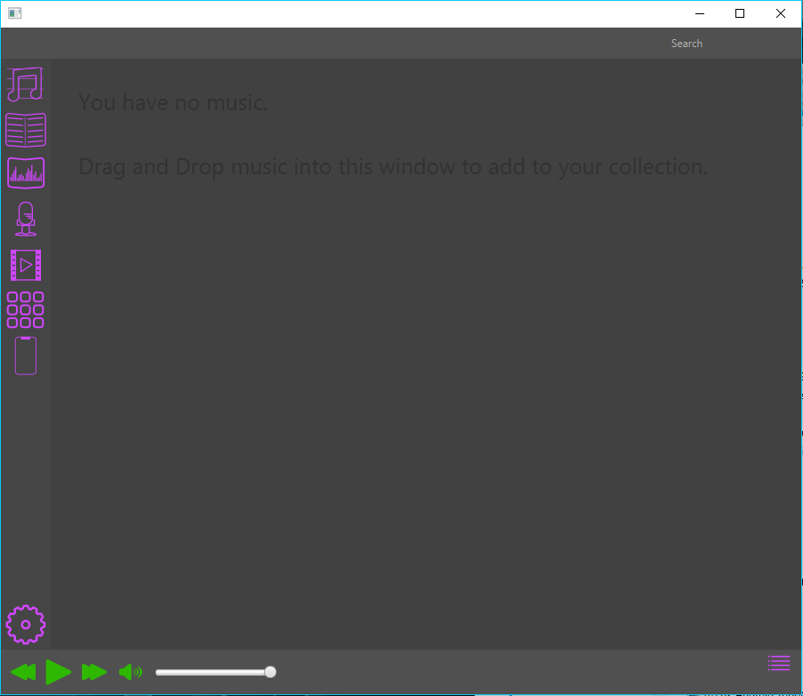

### 3 Content

#### 3.1 General

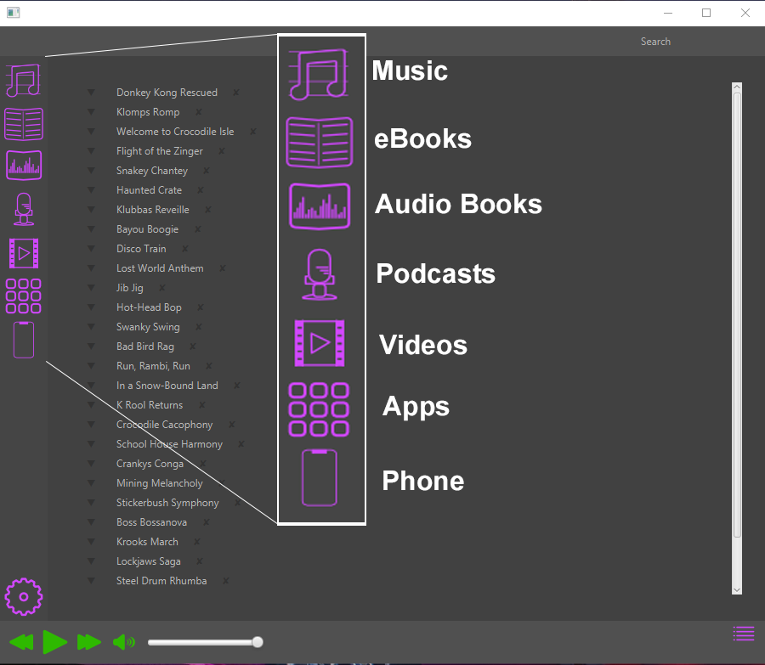

#### 3.2 Adding Content

Click on the option for the type of content you are adding, and then drag and drop it into the window

#### 3.3 Renaming Content

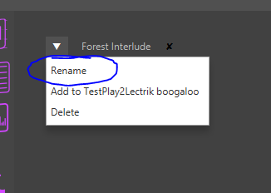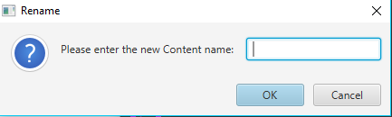

Click the arrow next to the content and select rename. Then enter the new name and select ok.

#### 3.4 Viewing Content

Click on the content you would like to play or watch and it will start

#### 3.5 Removing Content

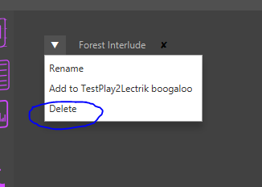

Click the arrow next to the content you would like to delete. Then click delete in the drop-down menu.

#### 3.6 Content Sync Status

Next to every piece of content is either an x mark or a check mark. The check indicates that a piece of content is set to sync to your phone when you wish to do so. The x means that content is not set to sync. To change them simply press the x or check and they will flip.

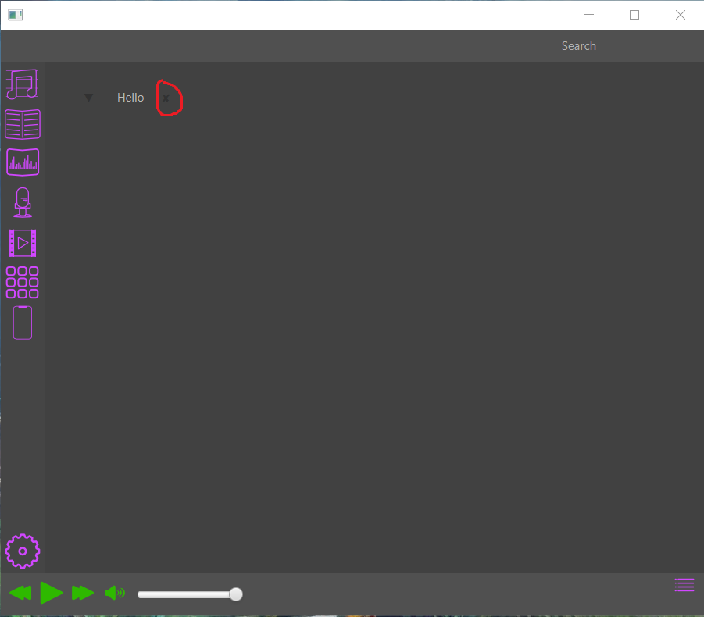

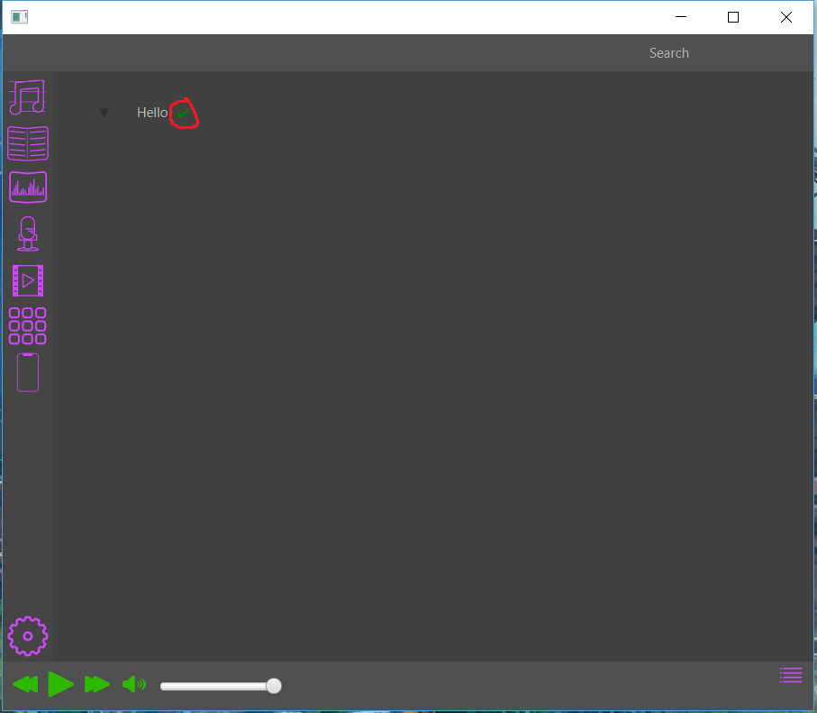

### 4 Podcasts

#### 4.1 Downloading Podcasts

Step One

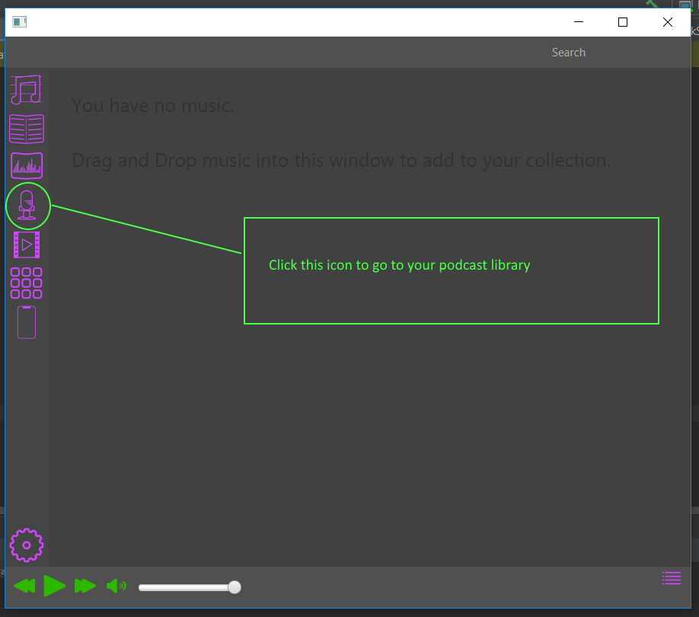

Step Two

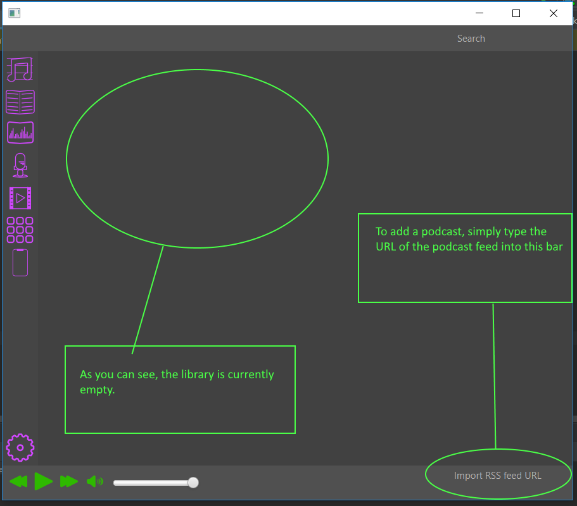

Step Three

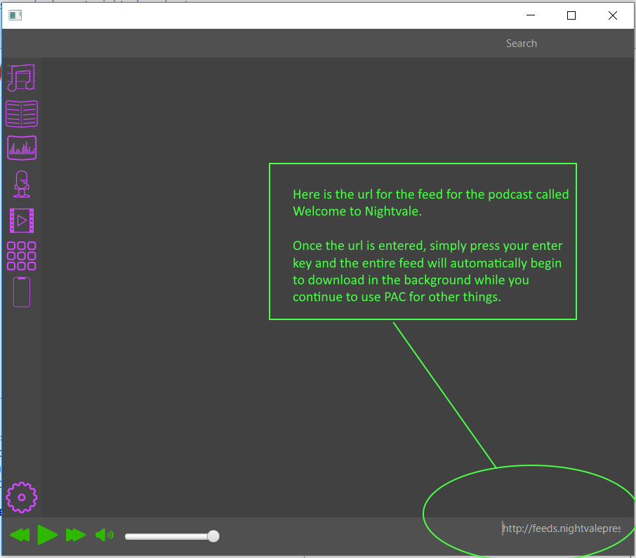

Step Four

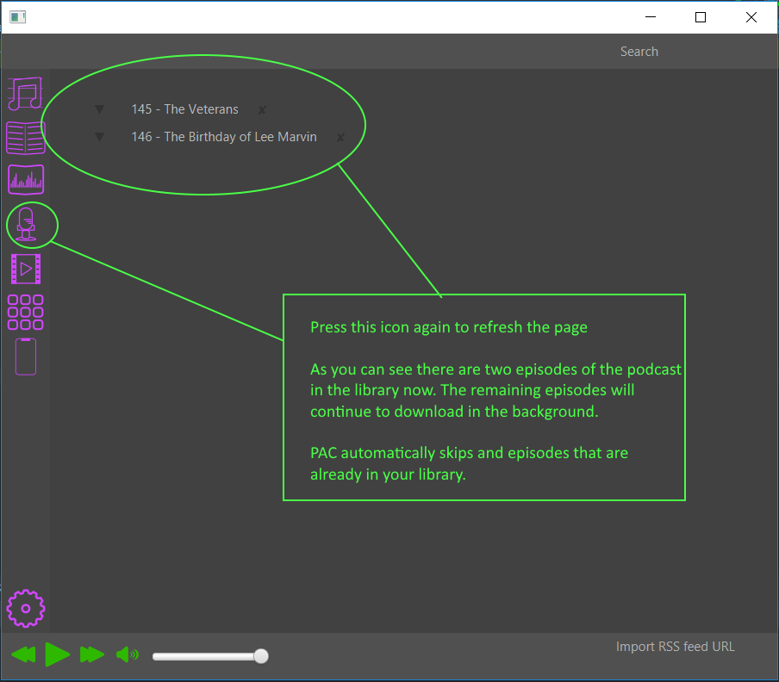

### 5 Books

#### 5.1 Looking up books via ISBN and seeing you recommendations

Step One

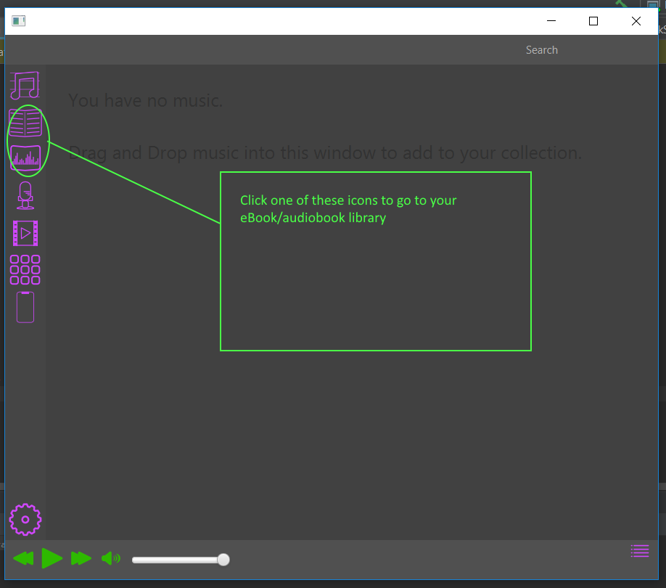

Step Two

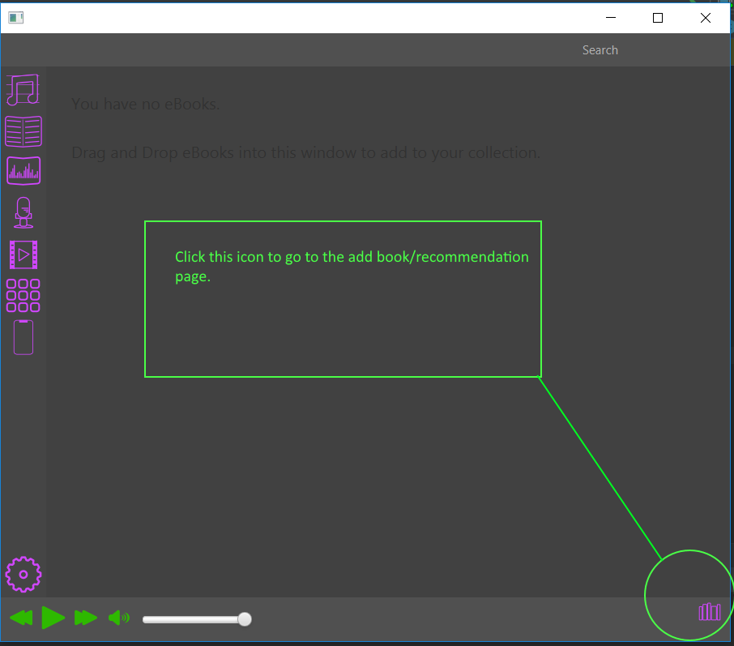

Step Three

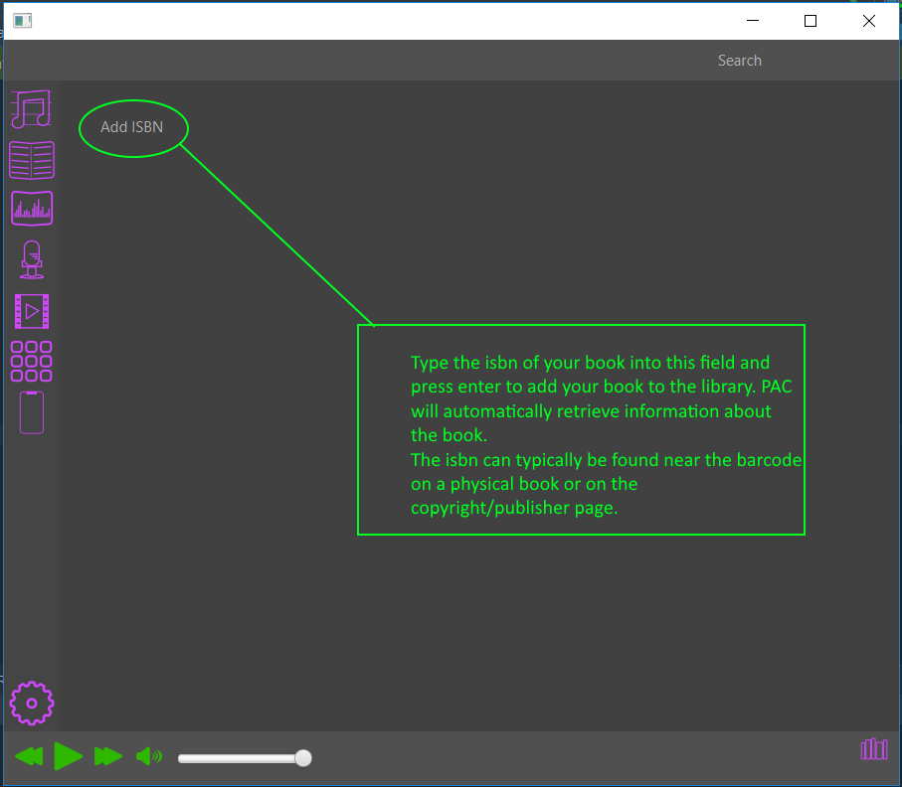

Step Four

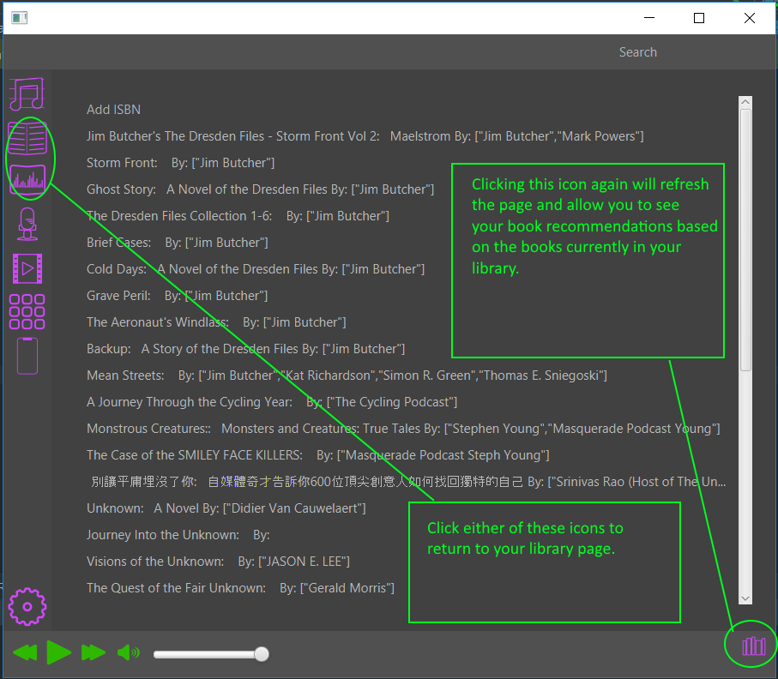

### 

### 

### 

### 

### 

### 

### 

### 

### 

### 

### 

### 

### 

### 

### 

### 6 Playlists

#### 6.1 Adding Playlists

To add playlists you need to go to the music menu if you are not there already. Then, in the bottom right corner, a button with 4 lines will take you to the playlists menu. If you have playlists here you’ll see them as large buttons.

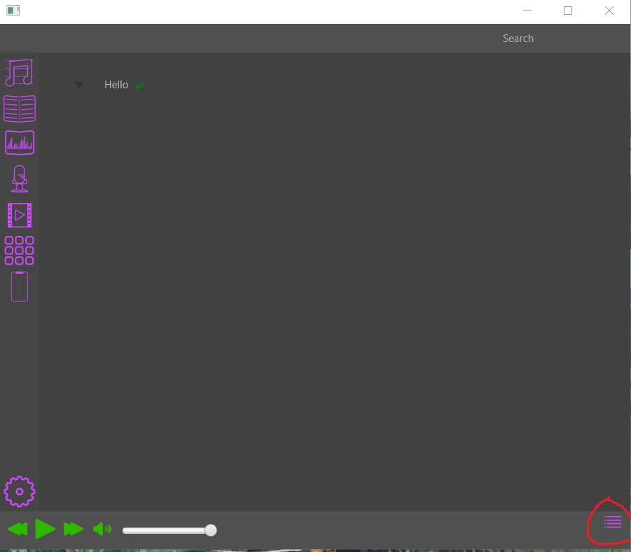

At the bottom, there will be a giant plus sign that says add playlist. Pressing the button will open a prompt to set the playlist name. Give it a name, press enter and reload the page by pressing the button on the bottom right again. Your playlist will load in.

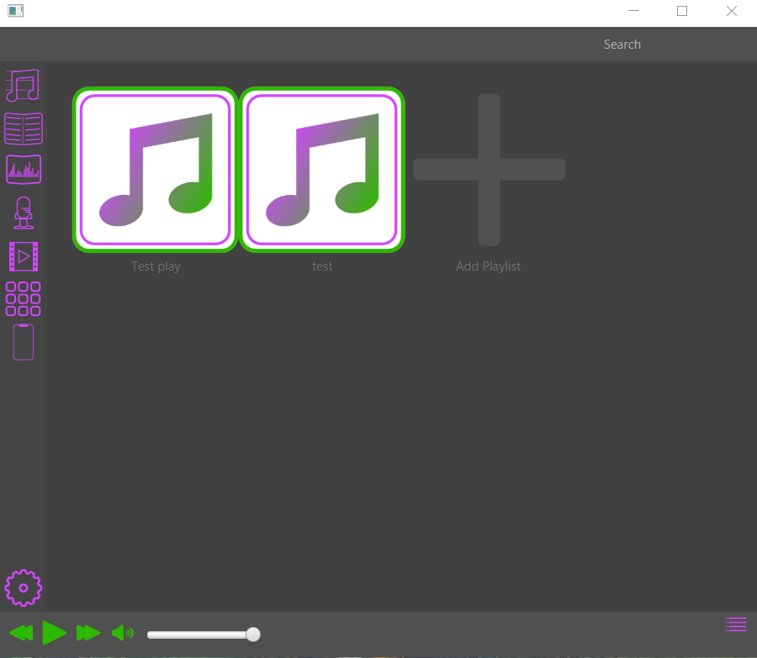

#### 6.2 Adding Content to a Playlist

To add content to a playlist go to the tab that holds your content. Click the triangle next to the piece of content you wish to add. A menu will appear that offers things like rename, delete and add to X. X here represents a playlist name. There will be a separate button to add content to any of your playlists. Press the button that adds the content to the playlist you want. The content will be added into it successfully. To enjoy the playlist go to the playlist menu and click on the playlist you want. You will be presented with a new view that shows all the content that exists in that playlist. Click the content like you normally would and enjoy.

#### 6.3 Delete a Playlist

Once you’re in your select playlist at the top there will be a button that says delete playlist. Once pressed reload the playlist page. Your playlist will be deleted.

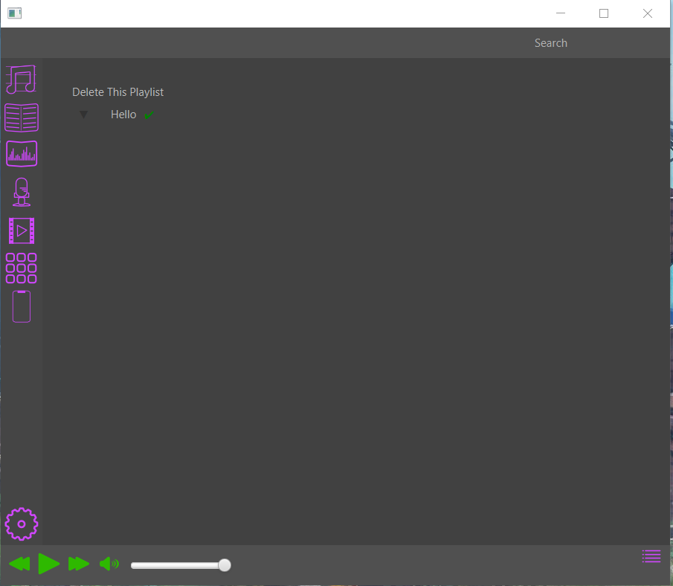

### 7 Apps

Apps work just the same as any other piece of content. Go over to the app menu, and drag and drop the app you would like to add. They will be added to the database and once you’ve reloaded the app menu you should see a button created for the app you added. Press the button of your desired app and it will work just like it normally would.

### 8 Android Device

#### 8.1 Syncing to Device

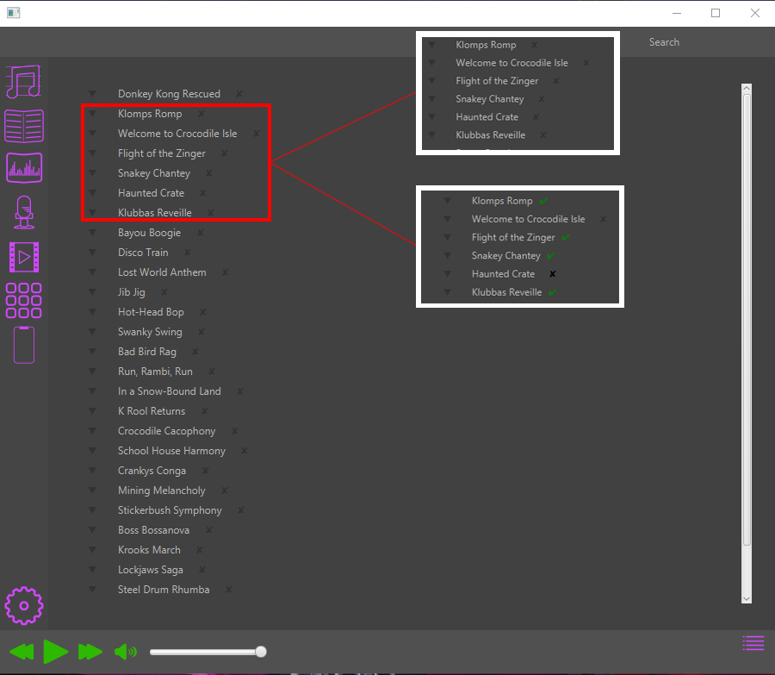

Click the “X” next to the media file you want sync. The Green check mark means that the file is ready to sync. To undo the sync, click the green check mark to turn it back into an “X”.

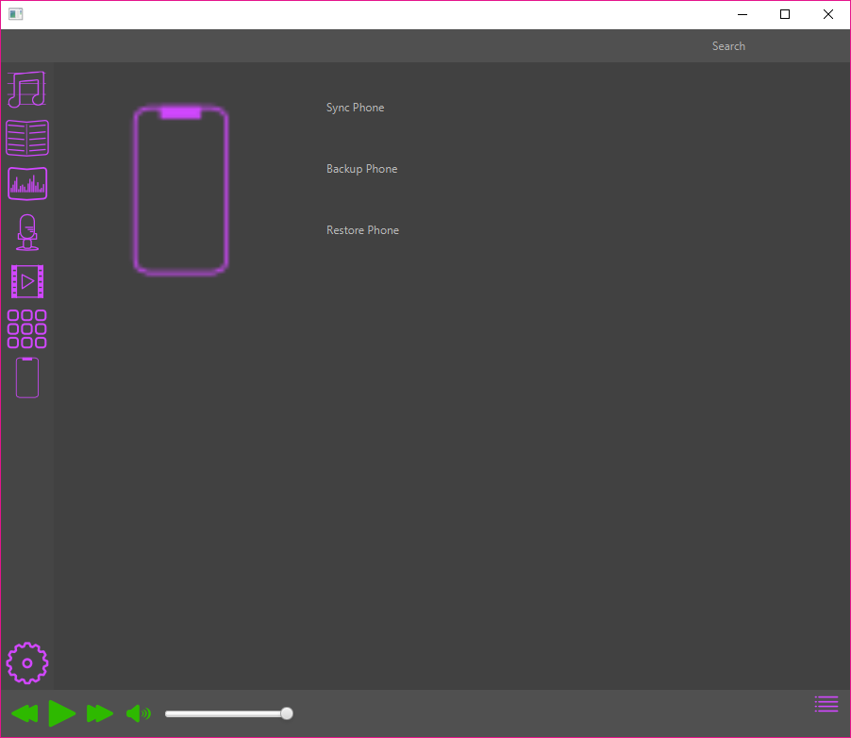

Click the Phone Button to go into the phone window, and then click “Sync Phone” to download all of the previously checked files to the device.

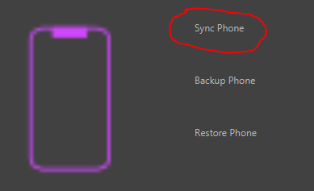

#### 8.2 Backing up Device

Click the “Backup Phone” option in the phone menu to back-up the device.

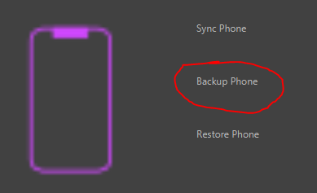

#### 8.3 Restoring Device

Click the “Restore Phone” option in the phone menu to back-up the device.

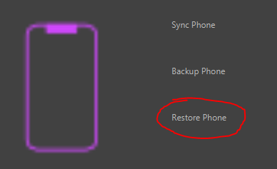

**9 Options Menu**